AdventureWorks Sales Analytics
Query Results Report: business question, SQL query and SSMS result
Prepared by Azeem Khan, Data Analyst | azeemkhanmev2@gmail.com | linkedin.com/in/azeem--khan | github.com/AzeemDataAnalyst
Database | AdventureWorks2025 (SQL Server 2025, SSMS). 2025 is the database version, not the data period.
Order data period | 30 May 2022 to 29 Jun 2025 (1,126 days). 2022 and 2025 are partial years.
Volume | 31,465 orders | 19,119 customers with orders | $123.2M total revenue (TotalDue)
Revenue measures | TotalDue includes tax and freight. Product and category figures use LineTotal (product sales only).

Key findings at a glance
Scale: 31,465 orders, 19,119 customers and $123.2M total revenue ($109.8M product sales, $13.4M tax and freight) from 30 May 2022 to 29 Jun 2025 (Q21).
Concentration: The top 10% of customers bring 81.9% of revenue. The 635 reseller customers (3.3% of customers) bring 73.7%, and 95% of them reorder (Q23, Q24, Q29).
Profitability: Bikes are 86% of product sales but earn only an 8.4% margin; Accessories are 1.2% of sales but earn 50%. Helmets appear in 7 of the top 10 product pairs, so bundling helmets with bikes is a clear profit lever (Q22, Q30).
Growth: 2024 revenue grew 38% over 2023, and through April 2025 it is 74% above April 2024. The growth came from individual customers: their orders rose from 1,220 to 4,882 in 2024-Q3, which pulled the average order value from $7.6K to $2.7K (Q17, V4, V5).
Territories: From 2023 to 2024, Germany (+373%), France (+146%), the UK (+131%) and Australia (+102%) grew fastest, while the reseller-heavy Central, Northeast and Southeast were flat or down (Q27, V6).
Customers: 1,075 customers have not ordered for 12+ months. 503 'At Risk' customers hold $17.4M of spend and are the first retention target (Q15, Q26).
Seasonality: June and July are the strongest months (index 147 and 133) and January and February the weakest (66 and 60) (Q31).
Data quality: From 30 May 2025 the average order value collapses from about $980 to about $58, so May and June 2025 were excluded from trend statements (V2, V3, Q32).

Section 1: Exploratory analysis (01_exploratory_analysis.sql)
Q1. Row counts of the key tables
Question: How much data do we have in each core table?
SQL QUERY
SELECT 'SalesOrderHeader' AS TableName, COUNT(*) AS [RowCount] FROM Sales.SalesOrderHeader
UNION ALL
SELECT 'SalesOrderDetail', COUNT(*) FROM Sales.SalesOrderDetail
UNION ALL
SELECT 'Product', COUNT(*) FROM Production.Product
UNION ALL
SELECT 'Customer', COUNT(*) FROM Sales.Customer;
RESULT (SSMS output)
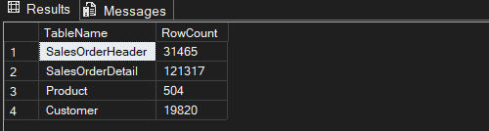
SalesOrderHeader = 31,465 | SalesOrderDetail = 121,317 | Product = 504 | Customer = 19,820
Insight: The tables restored correctly, and the order volume is large enough for trend analysis.
Q2. Date range of the data
Question: What period do the orders cover?
SQL QUERY
SELECT
MIN(OrderDate) AS EarliestOrder,
MAX(OrderDate) AS LatestOrder,
DATEDIFF(DAY, MIN(OrderDate), MAX(OrderDate)) AS TotalDaysCovered
FROM Sales.SalesOrderHeader;
RESULT (SSMS output)
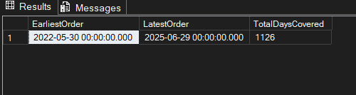
EarliestOrder = 2022-05-30 | LatestOrder = 2025-06-29 | TotalDaysCovered = 1,126 days (about 3 years)
Insight: The data runs from 30 May 2022 to 29 June 2025, so 2022 and 2025 are partial years. “2025” in AdventureWorks2025 is the database version, not the data period.
Q3. NULL check on key columns
Question: Are the key columns complete?
SQL QUERY
SELECT
SUM(CASE WHEN CustomerID IS NULL THEN 1 ELSE 0 END) AS Null_CustomerID,
SUM(CASE WHEN TerritoryID IS NULL THEN 1 ELSE 0 END) AS Null_TerritoryID,
SUM(CASE WHEN TotalDue IS NULL THEN 1 ELSE 0 END) AS Null_TotalDue
FROM Sales.SalesOrderHeader;
RESULT (SSMS output)
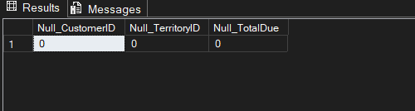
Null_CustomerID = 0 | Null_TerritoryID = 0 | Null_TotalDue = 0
Insight: No missing values in the columns used for joins and revenue, so the later analysis can rely on them.
Q4. Total revenue overview
Question: What are the headline numbers?
SQL QUERY
SELECT
COUNT(DISTINCT SalesOrderID) AS TotalOrders,
COUNT(DISTINCT CustomerID) AS TotalCustomers,
SUM(TotalDue) AS TotalRevenue,
AVG(TotalDue) AS AvgOrderValue
FROM Sales.SalesOrderHeader;
RESULT (SSMS output)
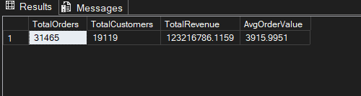
TotalOrders = 31,465 | TotalCustomers = 19,119 | TotalRevenue = $123,216,786.12 | AvgOrderValue = $3,915.99
Insight: These four numbers are the headline figures of the whole project. TotalRevenue uses TotalDue, which includes tax and freight.
Q5. Orders by year
Question: How do orders and revenue change by year?
SQL QUERY
SELECT
YEAR(OrderDate) AS OrderYear,
COUNT(*) AS TotalOrders,
SUM(TotalDue) AS TotalRevenue
FROM Sales.SalesOrderHeader
GROUP BY YEAR(OrderDate)
ORDER BY OrderYear;
RESULT (SSMS output)
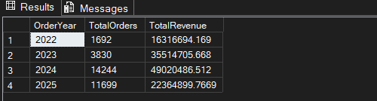
CHART
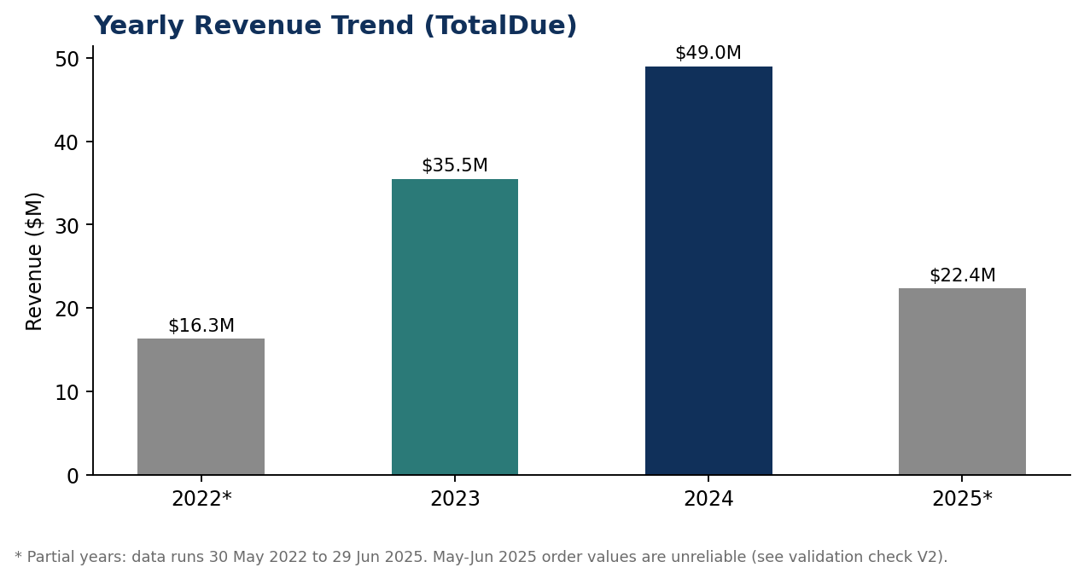
2022: 1,692 orders, $16.3M | 2023: 3,830 orders, $35.5M | 2024: 14,244 orders, $49.0M | 2025: 11,699 orders, $22.4M
Insight: 2024 is the best full year (+38% vs 2023). 2022 starts on 30 May and 2025 ends on 29 June, so those two totals cover only part of the year.

Section 2: Business questions (02_business_questions.sql)
Q6. Total sales by territory
Question: Which regions bring in the most revenue?
SQL QUERY
SELECT
st.Name AS Territory,
COUNT(DISTINCT soh.SalesOrderID) AS TotalOrders,
SUM(soh.TotalDue) AS TotalRevenue
FROM Sales.SalesOrderHeader soh
JOIN Sales.SalesTerritory st ON soh.TerritoryID = st.TerritoryID
GROUP BY st.Name
ORDER BY TotalRevenue DESC;
RESULT (SSMS output)
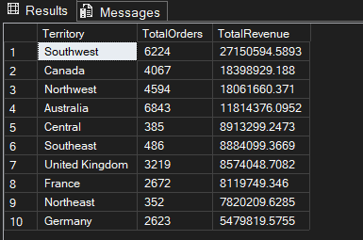
CHART
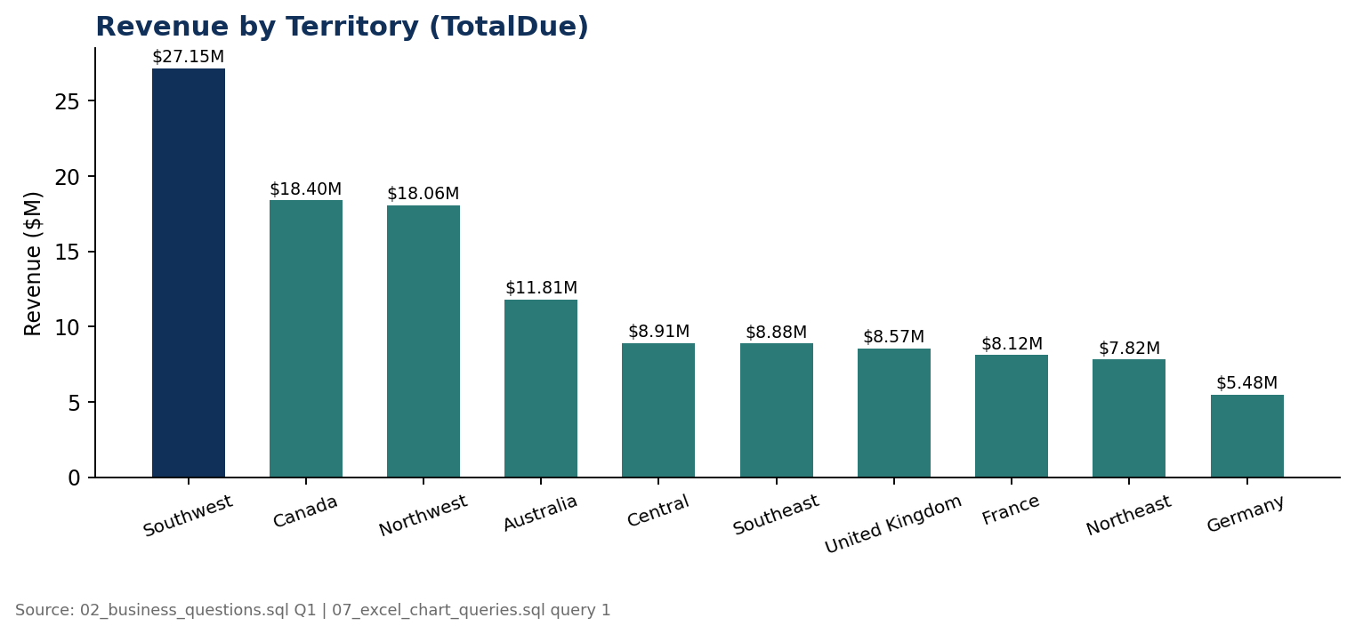
Southwest: 6,224 orders, $27,150,594.59 | Canada: 4,067 orders, $18,398,929.19 | Northwest: 4,594 orders, $18,061,660.37 | ... | Germany (lowest): 2,623 orders, $5,479,819.58
Insight: Southwest leads, about 48% ahead of Canada. Central, Northeast and Southeast earn about $8M from only 350 to 490 orders each, which points to large-order sales, while Germany has 2,623 orders for $5.5M. So territories should be compared on order value and customer mix as well as revenue.
Q7. Top 10 best-selling products
Question: Which products generate the most revenue?
SQL QUERY
SELECT TOP 10
p.Name AS ProductName,
SUM(sod.OrderQty) AS UnitsSold,
SUM(sod.LineTotal) AS TotalRevenue
FROM Sales.SalesOrderDetail sod
JOIN Production.Product p ON sod.ProductID = p.ProductID
GROUP BY p.Name
ORDER BY TotalRevenue DESC;
RESULT (SSMS output)
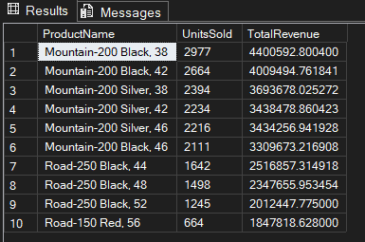
#1 Mountain-200 Black, 38: 2,977 units, $4,400,592.80 | #2 Mountain-200 Black, 42: 2,664 units, $4,009,494.76 | #3 Mountain-200 Silver, 38: 2,394 units, $3,693,678.03 | #10 Road-150 Red, 56: 664 units, $1,847,818.63
Insight: Six of the top 10 products are Mountain-200 variants, three are Road-250 Black and one is Road-150 Red. Together the top 10 bring in about $31.0M, roughly 28% of all product sales ($109.8M).
Q8. Revenue contribution by product category
Question: How much does each category contribute to product sales?
SQL QUERY
WITH CategoryRevenue AS (
SELECT
pc.Name AS Category,
SUM(sod.LineTotal) AS CategoryTotal
FROM Sales.SalesOrderDetail sod
JOIN Production.Product p ON sod.ProductID = p.ProductID
JOIN Production.ProductSubcategory psc ON p.ProductSubcategoryID = psc.ProductSubcategoryID
JOIN Production.ProductCategory pc ON psc.ProductCategoryID = pc.ProductCategoryID
GROUP BY pc.Name
)
SELECT
Category,
CategoryTotal,
CAST(CategoryTotal * 100.0 / SUM(CategoryTotal) OVER () AS DECIMAL(5,2)) AS PctOfTotalRevenue
FROM CategoryRevenue
ORDER BY CategoryTotal DESC;
RESULT (SSMS output)
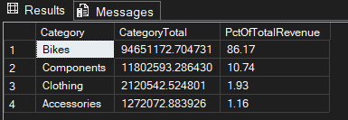
CHART
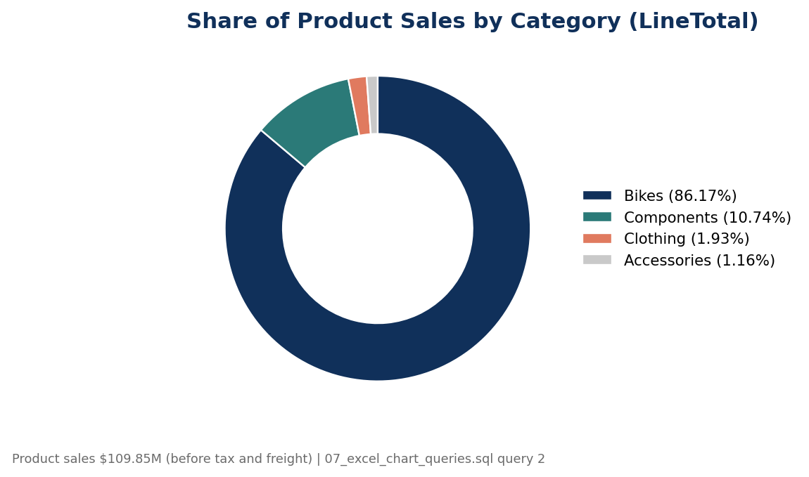
Bikes: $94,651,172.70 (86.17%) | Components: $11,802,593.29 (10.74%) | Clothing: $2,120,542.52 (1.93%) | Accessories: $1,272,072.88 (1.16%)
Insight: Bikes make up 86% of product sales, a clear concentration risk. The shares are calculated on LineTotal (product sales of $109.8M, before tax and freight), even though the column is named PctOfTotalRevenue.
Q9. Average order value by customer type
Question: Do reseller and individual customers behave differently?
SQL QUERY
SELECT
CASE WHEN c.StoreID IS NOT NULL THEN 'Store/Reseller' ELSE 'Individual' END AS CustomerType,
COUNT(DISTINCT soh.SalesOrderID) AS TotalOrders,
AVG(soh.TotalDue) AS AvgOrderValue
FROM Sales.SalesOrderHeader soh
JOIN Sales.Customer c ON soh.CustomerID = c.CustomerID
GROUP BY CASE WHEN c.StoreID IS NOT NULL THEN 'Store/Reseller' ELSE 'Individual' END;
RESULT (SSMS output)
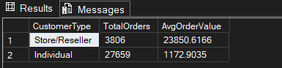
CHART
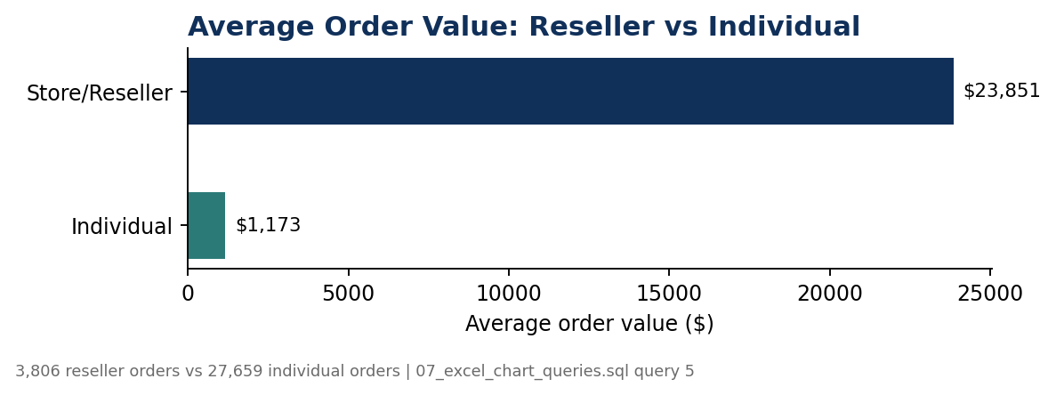
Store/Reseller: 3,806 orders, average order value $23,850.62 | Individual: 27,659 orders, average order value $1,172.90
Insight: A reseller order is worth about 20 times an individual order, and individuals place about 7 times as many orders. The two segments should be reported and targeted separately.
Q10. Top 10 customers by total spend
Question: Who are the highest-value customers?
SQL QUERY
SELECT TOP 10
soh.CustomerID,
SUM(soh.TotalDue) AS TotalSpend,
COUNT(soh.SalesOrderID) AS NumOrders
FROM Sales.SalesOrderHeader soh
GROUP BY soh.CustomerID
ORDER BY TotalSpend DESC;
RESULT (SSMS output)
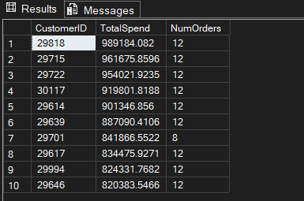
#1 Customer 29818: $989,184.08 in 12 orders | #2 Customer 29715: $961,675.86 in 12 orders | #3 Customer 29722: $954,021.92 in 12 orders | #10 Customer 29646: $820,383.55 in 12 orders
Insight: The top 10 customers each spent between $0.82M and $0.99M. Nine of them placed 12 orders; Customer 29701 placed 8. Their spend per order (about $68K to $105K) is far above the $1,173 individual average from Q9, which points to reseller accounts.

Section 3: Window functions (03_window_functions.sql)
Q11. Month-over-month sales growth
Question: How does revenue change from one month to the next?
SQL QUERY
WITH MonthlySales AS (
SELECT
YEAR(OrderDate) AS SalesYear,
MONTH(OrderDate) AS SalesMonth,
SUM(TotalDue) AS MonthlyRevenue
FROM Sales.SalesOrderHeader
GROUP BY YEAR(OrderDate), MONTH(OrderDate)
)
SELECT
SalesYear,
SalesMonth,
MonthlyRevenue,
LAG(MonthlyRevenue) OVER (ORDER BY SalesYear, SalesMonth) AS PrevMonthRevenue,
CAST(
(MonthlyRevenue - LAG(MonthlyRevenue) OVER (ORDER BY SalesYear, SalesMonth))
* 100.0 / NULLIF(LAG(MonthlyRevenue) OVER (ORDER BY SalesYear, SalesMonth), 0)
AS DECIMAL(6,2)) AS MoM_Growth_Pct
FROM MonthlySales
ORDER BY SalesYear, SalesMonth;
RESULT (SSMS output)
SalesYear | SalesMonth | MonthlyRevenue | PrevMonthRevenue | MoM_Growth_Pct
2022 | 5 | $582,415.28 | NULL | NULL
2022 | 6 | $2,244,313.14 | $582,415.28 | 285.35%
2022 | 7 | $1,868,508.36 | $2,244,313.14 | -16.74%
2022 | 8 | $1,483,277.04 | $1,868,508.36 | -20.62%
2022 | 9 | $3,183,714.32 | $1,483,277.04 | 114.64%
2022 | 10 | $2,543,935.27 | $3,183,714.32 | -20.1%
2022 | 11 | $1,603,313.51 | $2,543,935.27 | -36.98%
2022 | 12 | $2,807,217.25 | $1,603,313.51 | 75.09%
2023 | 1 | $2,325,568.60 | $2,807,217.25 | -17.16%
2023 | 2 | $1,620,826.10 | $2,325,568.60 | -30.3%
2023 | 3 | $3,336,347.47 | $1,620,826.10 | 105.84%
2023 | 4 | $1,871,923.50 | $3,336,347.47 | -43.89%
2023 | 5 | $3,452,924.45 | $1,871,923.50 | 84.46%
2023 | 6 | $4,610,647.22 | $3,452,924.45 | 33.53%
2023 | 7 | $3,840,231.46 | $4,610,647.22 | -16.71%
2023 | 8 | $2,442,451.18 | $3,840,231.46 | -36.4%
2023 | 9 | $3,881,724.19 | $2,442,451.18 | 58.93%
2023 | 10 | $2,858,060.20 | $3,881,724.19 | -26.37%
2023 | 11 | $2,097,153.13 | $2,858,060.20 | -26.62%
2023 | 12 | $3,176,848.17 | $2,097,153.13 | 51.48%
2024 | 1 | $2,340,061.55 | $3,176,848.17 | -26.34%
2024 | 2 | $2,629,322.45 | $2,340,061.55 | 12.36%
2024 | 3 | $3,826,046.07 | $2,629,322.45 | 45.51%
2024 | 4 | $2,841,585.78 | $3,826,046.07 | -25.73%
2024 | 5 | $3,672,137.65 | $2,841,585.78 | 29.23%
2024 | 6 | $5,707,181.09 | $3,672,137.65 | 55.42%
2024 | 7 | $5,546,401.07 | $5,707,181.09 | -2.82%
2024 | 8 | $3,724,394.90 | $5,546,401.07 | -32.85%
2024 | 9 | $5,091,152.26 | $3,724,394.90 | 36.7%
2024 | 10 | $5,401,903.75 | $5,091,152.26 | 6.1%
2024 | 11 | $3,671,582.38 | $5,401,903.75 | -32.03%
2024 | 12 | $4,568,717.58 | $3,671,582.38 | 24.43%
2025 | 1 | $4,783,231.67 | $4,568,717.58 | 4.7%
2025 | 2 | $3,987,943.63 | $4,783,231.67 | -16.63%
2025 | 3 | $5,585,675.81 | $3,987,943.63 | 40.06%
2025 | 4 | $5,847,164.69 | $5,585,675.81 | 4.68%
2025 | 5 | $2,108,405.79 | $5,847,164.69 | -63.94%
2025 | 6 | $52,478.19 | $2,108,405.79 | -97.51%

38 months of data (37 month-over-month changes). Highest: +285.35% (Jun 2022). Lowest: -97.51% (Jun 2025). 25 of the 37 changes fall between -35% and +55%.
Insight: The +285% in Jun 2022 is measured against May 2022, which holds only the last 2 days of data (30 and 31 May), so it is not real growth. At the other end, revenue falls to $2.11M in May 2025 (-63.94%) and to just $52,478 in Jun 2025 (-97.51%), after $5.6M to $5.8M in Mar and Apr 2025. The data runs to 29 June, so this looks like the dataset thinning out at its end rather than a business collapse; confirm it with the daily order counts in 05_validation_checks.sql before presenting it as a finding. Excluding these three months, the changes range from -43.89% to +114.64%.
Q12. Running total of revenue through the year
Question: How does revenue build up within each year?
SQL QUERY
SELECT
YEAR(OrderDate) AS SalesYear,
MONTH(OrderDate) AS SalesMonth,
SUM(TotalDue) AS MonthlyRevenue,
SUM(SUM(TotalDue)) OVER (
PARTITION BY YEAR(OrderDate)
ORDER BY MONTH(OrderDate)
ROWS BETWEEN UNBOUNDED PRECEDING AND CURRENT ROW
) AS RunningYearTotal
FROM Sales.SalesOrderHeader
GROUP BY YEAR(OrderDate), MONTH(OrderDate)
ORDER BY SalesYear, SalesMonth;
RESULT (SSMS output)
SalesYear | SalesMonth | MonthlyRevenue | RunningYearTotal
2022 | 5 | $582,415.28 | $582,415.28
2022 | 6 | $2,244,313.14 | $2,826,728.42
2022 | 7 | $1,868,508.36 | $4,695,236.78
2022 | 8 | $1,483,277.04 | $6,178,513.82
2022 | 9 | $3,183,714.32 | $9,362,228.14
2022 | 10 | $2,543,935.27 | $11,906,163.41
2022 | 11 | $1,603,313.51 | $13,509,476.92
2022 | 12 | $2,807,217.25 | $16,316,694.17
2023 | 1 | $2,325,568.60 | $2,325,568.60
2023 | 2 | $1,620,826.10 | $3,946,394.70
2023 | 3 | $3,336,347.47 | $7,282,742.17
2023 | 4 | $1,871,923.50 | $9,154,665.68
2023 | 5 | $3,452,924.45 | $12,607,590.13
2023 | 6 | $4,610,647.22 | $17,218,237.35
2023 | 7 | $3,840,231.46 | $21,058,468.80
2023 | 8 | $2,442,451.18 | $23,500,919.99
2023 | 9 | $3,881,724.19 | $27,382,644.17
2023 | 10 | $2,858,060.20 | $30,240,704.37
2023 | 11 | $2,097,153.13 | $32,337,857.50
2023 | 12 | $3,176,848.17 | $35,514,705.67
2024 | 1 | $2,340,061.55 | $2,340,061.55
2024 | 2 | $2,629,322.45 | $4,969,384.00
2024 | 3 | $3,826,046.07 | $8,795,430.07
2024 | 4 | $2,841,585.78 | $11,637,015.85
2024 | 5 | $3,672,137.65 | $15,309,153.49
2024 | 6 | $5,707,181.09 | $21,016,334.58
2024 | 7 | $5,546,401.07 | $26,562,735.65
2024 | 8 | $3,724,394.90 | $30,287,130.55
2024 | 9 | $5,091,152.26 | $35,378,282.81
2024 | 10 | $5,401,903.75 | $40,780,186.55
2024 | 11 | $3,671,582.38 | $44,451,768.94
2024 | 12 | $4,568,717.58 | $49,020,486.51
2025 | 1 | $4,783,231.67 | $4,783,231.67
2025 | 2 | $3,987,943.63 | $8,771,175.29
2025 | 3 | $5,585,675.81 | $14,356,851.10
2025 | 4 | $5,847,164.69 | $20,204,015.79
2025 | 5 | $2,108,405.79 | $22,312,421.58
2025 | 6 | $52,478.19 | $22,364,899.77

The running total restarts each January and ends at the yearly total: 2022 = $16,316,694.17 | 2023 = $35,514,705.67 | 2024 = $49,020,486.51 | 2025 (to June) = $22,364,899.77
Insight: The December values match the yearly totals in Q5 exactly, so the two queries agree. Compared on the same months, the running total at the end of April is $20.20M in 2025 against $11.64M in 2024, which is +74%. The Jan to Jun comparison (+6%) is lower only because May and June 2025 are unusually low (see Q11).
Q13. Top 3 products per category
Question: Which products lead within each category?
SQL QUERY
WITH ProductRevenue AS (
SELECT
pc.Name AS Category,
p.Name AS Product,
SUM(sod.LineTotal) AS Revenue
FROM Sales.SalesOrderDetail sod
JOIN Production.Product p ON sod.ProductID = p.ProductID
JOIN Production.ProductSubcategory psc ON p.ProductSubcategoryID = psc.ProductSubcategoryID
JOIN Production.ProductCategory pc ON psc.ProductCategoryID = pc.ProductCategoryID
GROUP BY pc.Name, p.Name
),
RankedProducts AS (
SELECT
Category, Product, Revenue,
RANK() OVER (PARTITION BY Category ORDER BY Revenue DESC) AS RevenueRank
FROM ProductRevenue
)
SELECT * FROM RankedProducts WHERE RevenueRank <= 3
ORDER BY Category, RevenueRank;
RESULT (SSMS output)
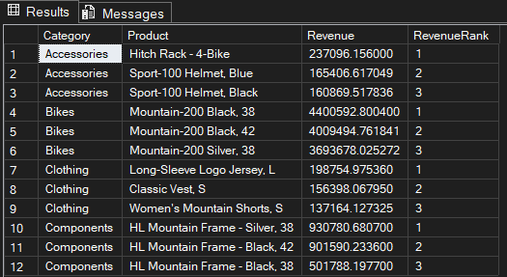
Bikes #1: Mountain-200 Black, 38 ($4,400,592.80) | Components #1: HL Mountain Frame - Silver, 38 ($930,780.68) | Clothing #1: Long-Sleeve Logo Jersey, L ($198,754.98) | Accessories #1: Hitch Rack - 4-Bike ($237,096.16)
Insight: PARTITION BY Category restarts the ranking in every category, giving 12 rows (3 per category). The top 3 Bikes are all Mountain-200 models, the top 3 Components are all HL Mountain Frames, and the leading Accessories are a bike rack and two Sport-100 helmets. The best Bike alone earns about 18 times the best Accessory.
Q14. Salesperson ranking by YTD sales
Question: How do salespeople rank by SalesYTD, with their quota shown alongside?
SQL QUERY
SELECT
sp.BusinessEntityID,
per.FirstName + ' ' + per.LastName AS SalesPersonName,
sp.SalesYTD,
sp.SalesQuota,
DENSE_RANK() OVER (ORDER BY sp.SalesYTD DESC) AS PerformanceRank
FROM Sales.SalesPerson sp
JOIN Person.Person per ON sp.BusinessEntityID = per.BusinessEntityID
ORDER BY PerformanceRank;
RESULT (SSMS output)
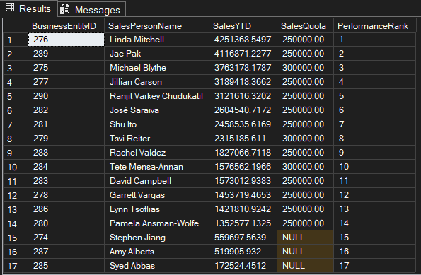
17 salespeople. #1 Linda Mitchell: SalesYTD $4,251,368.55 against a quota of $250,000 | #2 Jae Pak: $4,116,871.23 | #3 Michael Blythe: $3,763,178.18 | #17 Syed Abbas: $172,524.45
Insight: DENSE_RANK gives ranks 1 to 17 without gaps; no two salespeople are tied. Three salespeople (ranks 15 to 17: Stephen Jiang, Amy Alberts and Syed Abbas) have a NULL quota, a data-quality point to mention. The ranking uses SalesYTD only. SalesYTD is an accumulated figure, so its ratio to the quota (5.4 times for rank 14, 17 times for rank 1) is only indicative.

Section 4: CTEs and segmentation (04_cte_advanced_queries.sql)
Q15. Customers with no order in the last 12 months
Question: Which customers have gone quiet?
SQL QUERY
WITH LastOrderPerCustomer AS (
SELECT
CustomerID,
MAX(OrderDate) AS LastOrderDate
FROM Sales.SalesOrderHeader
GROUP BY CustomerID
),
MostRecentDateInData AS (
SELECT MAX(OrderDate) AS MaxDate FROM Sales.SalesOrderHeader
)
SELECT
l.CustomerID,
l.LastOrderDate,
DATEDIFF(MONTH, l.LastOrderDate, m.MaxDate) AS MonthsSinceLastOrder
FROM LastOrderPerCustomer l
CROSS JOIN MostRecentDateInData m
WHERE DATEDIFF(MONTH, l.LastOrderDate, m.MaxDate) >= 12
ORDER BY MonthsSinceLastOrder DESC;
RESULT (SSMS output)
Result summary: customers by months since last order
MonthsSinceLastOrder | Customers
12 months | 394
13 to 18 months | 252
19 to 24 months | 111
25 to 30 months | 135
31 to 37 months | 183
Total | 1,075

Result rows: the 20 most dormant customers (first 20 of 1,075 rows)
CustomerID | MonthsSinceLastOrder
28389 | 37
26620 | 36
29385 | 36
27673 | 36
25861 | 36
27605 | 36
19802 | 36
27611 | 36
27614 | 36
27577 | 36
28390 | 36
27649 | 36
27666 | 36
25857 | 36
27612 | 36
27604 | 36
27578 | 36
27601 | 36
28039 | 35
28042 | 35

1,075 customers (about 5.6% of the 19,119 customers with orders) have not ordered for 12 or more months. The most dormant, Customer 28389, is 37 months behind the latest date in the data; it is the only customer at 37 months.
Insight: Recency is measured from the latest order date in the data (29 Jun 2025), not today's date, so the result does not depend on when the query is run. The 1,075 customers together spent $16.83M in total, and 94 of them are in a VIP segment (Q16), so this list can be prioritised by past spend for a win-back campaign. Note: the exported file lost the LastOrderDate values, so only CustomerID and MonthsSinceLastOrder are shown here.
Q16. Customer value segmentation (RFM-lite)
Question: How can customers be grouped by value (spend) and recency?
SQL QUERY
WITH CustomerStats AS (
SELECT
CustomerID,
MAX(OrderDate) AS LastOrderDate,
COUNT(SalesOrderID) AS OrderCount,
SUM(TotalDue) AS TotalSpend
FROM Sales.SalesOrderHeader
GROUP BY CustomerID
),
MaxDate AS (
SELECT MAX(OrderDate) AS MaxDate FROM Sales.SalesOrderHeader
)
SELECT
cs.CustomerID,
cs.TotalSpend,
cs.OrderCount,
DATEDIFF(MONTH, cs.LastOrderDate, m.MaxDate) AS MonthsSinceLastOrder,
CASE
WHEN cs.TotalSpend > 10000 AND DATEDIFF(MONTH, cs.LastOrderDate, m.MaxDate) <= 6 THEN 'VIP - Active'
WHEN cs.TotalSpend > 10000 THEN 'VIP - At Risk'
WHEN DATEDIFF(MONTH, cs.LastOrderDate, m.MaxDate) <= 6 THEN 'Regular - Active'
ELSE 'Regular - Dormant'
END AS CustomerSegment
FROM CustomerStats cs
CROSS JOIN MaxDate m
ORDER BY cs.TotalSpend DESC;
RESULT (SSMS output)
Result summary: customers per segment
CustomerSegment | Customers | TotalSpend | Share of spend
VIP - Active | 394 | $75,900,934.79 | 61.6%
VIP - At Risk | 111 | $14,759,456.36 | 12.0%
Regular - Active | 11,368 | $20,057,892.85 | 16.3%
Regular - Dormant | 7,246 | $12,498,502.11 | 10.1%
Total | 19,119 | $123,216,786.12 | 100%

Result rows: the top 12 customers by spend (first 12 of 19,119 rows)
CustomerID | TotalSpend | OrderCount | MonthsSinceLastOrder | CustomerSegment
29818 | $989,184.08 | 12 | 3 | VIP - Active
29715 | $961,675.86 | 12 | 2 | VIP - Active
29722 | $954,021.92 | 12 | 2 | VIP - Active
30117 | $919,801.82 | 12 | 3 | VIP - Active
29614 | $901,346.86 | 12 | 4 | VIP - Active
29639 | $887,090.41 | 12 | 2 | VIP - Active
29701 | $841,866.55 | 8 | 2 | VIP - Active
29617 | $834,475.93 | 12 | 3 | VIP - Active
29994 | $824,331.77 | 12 | 4 | VIP - Active
29646 | $820,383.55 | 12 | 4 | VIP - Active
29580 | $815,914.25 | 12 | 4 | VIP - Active
29827 | $801,766.21 | 12 | 4 | VIP - Active

19,119 rows, one per customer (matches TotalCustomers in Q4). The top row, Customer 29818 ($989,184.08, 12 orders), is segmented 'VIP - Active' and matches the top spender in Q10.
Insight: 505 VIP customers (about 2.6% of all customers) account for 73.6% of the total spend, $75.9M from 394 active VIPs plus $14.8M from 111 VIPs at risk. The summed customer spend equals the $123,216,786.12 total revenue from Q4, so no customer was lost or counted twice. The thresholds ($10,000 spend and 6 months) are analyst-chosen, and 'Regular - Dormant' means more than 6 months without an order, which is a wider group than the 12-month list in Q15. A full RFM model would also score order frequency.
Q17. Average order value trend by quarter
Question: How are order volume and order value changing over time?
SQL QUERY
WITH QuarterlyOrders AS (
SELECT
YEAR(OrderDate) AS OrderYear,
DATEPART(QUARTER, OrderDate) AS OrderQuarter,
TotalDue
FROM Sales.SalesOrderHeader
)
SELECT
OrderYear,
OrderQuarter,
COUNT(*) AS TotalOrders,
AVG(TotalDue) AS AvgOrderValue,
SUM(TotalDue) AS TotalRevenue
FROM QuarterlyOrders
GROUP BY OrderYear, OrderQuarter
ORDER BY OrderYear, OrderQuarter;
RESULT (SSMS output)
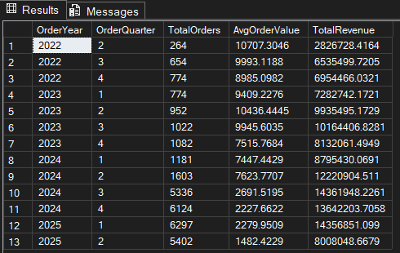
CHART
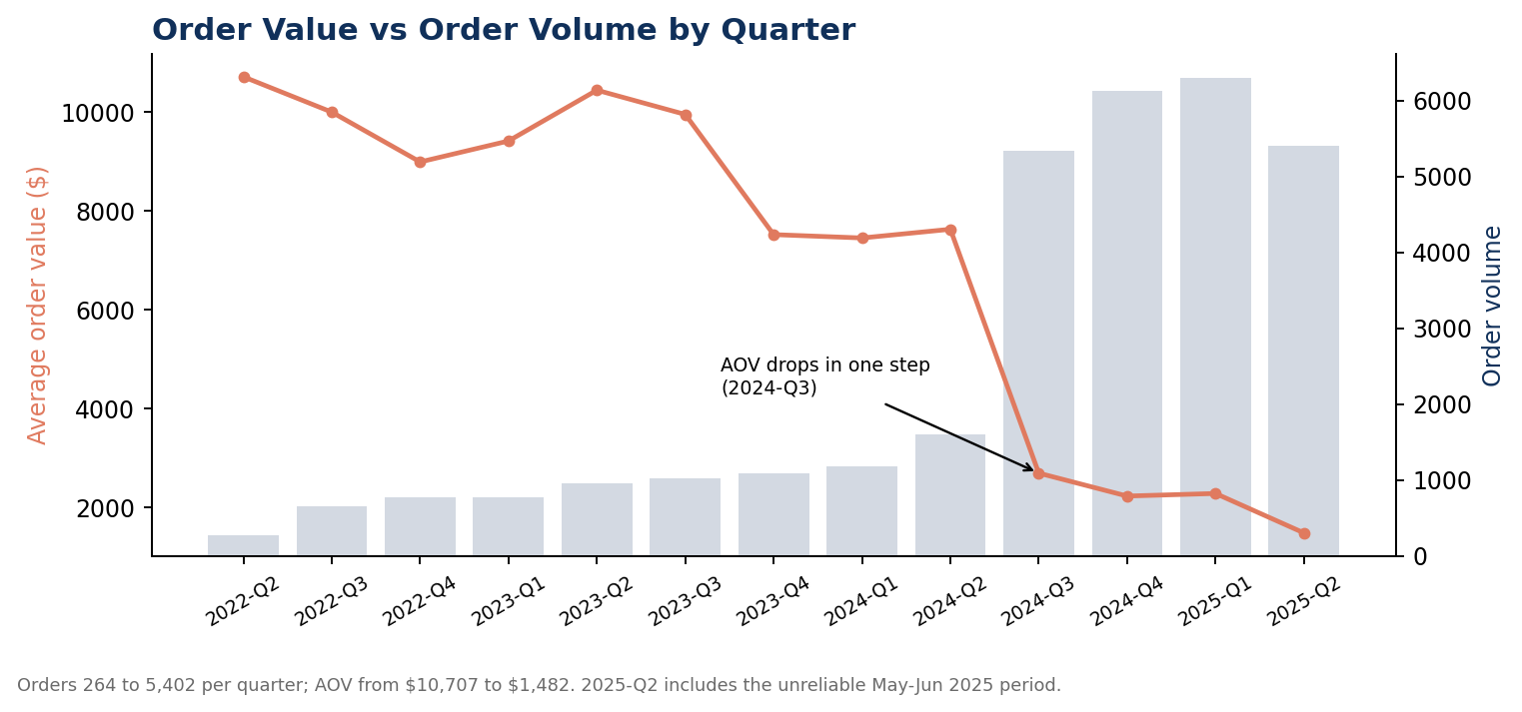
13 quarters. Orders grow from 264 (2022-Q2) to 5,402 (2025-Q2). Average order value falls from $10,707.30 (2022-Q2) to $1,482.42 (2025-Q2), with the sharpest drop in 2024-Q3 ($7,623.77 to $2,691.52).
Insight: Average order value stays between about $7,400 and $10,700 until 2024-Q2, then drops in one step. From 2024-Q2 to 2024-Q3 the number of orders rises 3.3 times (1,603 to 5,336) while revenue rises only 17% ($12.22M to $14.36M). This is consistent with growth coming from many small individual orders instead of large reseller orders; the quarter by customer type query in 05_validation_checks.sql confirms or rejects this. 2025-Q2 is also pulled down by the very low May and June 2025 figures (see Q11).

Section 5: Stored procedure and views (sp_monthly_sales_report.sql, reporting_views.sql)
Q18. sp_monthly_sales_report (stored procedure)
Question: Can the territory report for any month be produced on demand?
SQL QUERY
CREATE OR ALTER PROCEDURE dbo.sp_monthly_sales_report
@Year INT,
@Month INT
AS
BEGIN
SET NOCOUNT ON;

SELECT
st.Name AS Territory,
COUNT(DISTINCT soh.SalesOrderID) AS TotalOrders,
SUM(soh.TotalDue) AS TotalRevenue,
AVG(soh.TotalDue) AS AvgOrderValue,
COUNT(DISTINCT soh.CustomerID) AS UniqueCustomers
FROM Sales.SalesOrderHeader soh
JOIN Sales.SalesTerritory st ON soh.TerritoryID = st.TerritoryID
WHERE YEAR(soh.OrderDate) = @Year
AND MONTH(soh.OrderDate) = @Month
GROUP BY st.Name
ORDER BY TotalRevenue DESC;
END;

-- EXEC dbo.sp_monthly_sales_report @Year = 2022, @Month = 5;

-- Usage
EXEC dbo.sp_monthly_sales_report @Year = 2022, @Month = 5;
RESULT (SSMS output)
Territory | TotalOrders | TotalRevenue | AvgOrderValue
Southeast | 10 | $156,696.79 | $15,669.68
Canada | 8 | $133,887.76 | $16,735.97
Southwest | 9 | $117,401.60 | $13,044.62
Northwest | 7 | $109,490.70 | $15,641.53

For May 2022, 8 territories have orders. The four largest are shown above; smaller territories such as Australia and France have only 1 to 4 orders each.
Insight: May 2022 holds only the last 2 days of data (30 and 31 May), so these are small numbers by design. The parameters @Year and @Month turn a one-off query into a reusable report that Power BI or a scheduled job can call every month.
Q19. vw_SalesSummary (view)
Question: Can BI tools connect to one clean, pre-joined object instead of writing joins?
SQL QUERY
CREATE OR ALTER VIEW Sales.vw_SalesSummary AS
SELECT soh.SalesOrderID, soh.OrderDate,
YEAR(soh.OrderDate) AS OrderYear, MONTH(soh.OrderDate) AS OrderMonth,
st.Name AS Territory, soh.CustomerID, soh.TotalDue, soh.SalesPersonID
FROM Sales.SalesOrderHeader soh
JOIN Sales.SalesTerritory st ON soh.TerritoryID = st.TerritoryID;
RESULT (SSMS output)
SELECT COUNT(*) returns 31,465 rows, an exact match with the SalesOrderHeader row count (Q1). The latest OrderDate in the view is 2025-06-29, matching Q2.
Insight: The row count shows that the join neither dropped nor duplicated orders, so the view can safely feed Power BI or Excel.
Q20. vw_ProductPerformance (view)
Question: Can product-level results be pre-aggregated for a dashboard?
SQL QUERY
CREATE OR ALTER VIEW Sales.vw_ProductPerformance AS
SELECT p.ProductID, p.Name AS ProductName, pc.Name AS Category, psc.Name AS Subcategory,
SUM(sod.OrderQty) AS TotalUnitsSold,
SUM(sod.LineTotal) AS TotalRevenue,
AVG(sod.UnitPrice) AS AvgSellingPrice
FROM Sales.SalesOrderDetail sod
JOIN Production.Product p ON sod.ProductID = p.ProductID
JOIN Production.ProductSubcategory psc ON p.ProductSubcategoryID = psc.ProductSubcategoryID
JOIN Production.ProductCategory pc ON psc.ProductCategoryID = pc.ProductCategoryID
GROUP BY p.ProductID, p.Name, pc.Name, psc.Name;
RESULT (SSMS output)
Top row: Mountain-200 Black, 38 with TotalRevenue $4,400,592.80 and 2,977 units sold.
Insight: This is an exact match with the top product in Q7, so the view's pre-aggregation is consistent with the raw query. A Power BI bar chart of top products needs no further SQL.

Section 6: Advanced business analysis (06_advanced_analysis.sql)
Q21. Executive KPI summary
Question: What are the headline numbers of the whole business?
SQL QUERY
SELECT
COUNT(*) AS TotalOrders,
COUNT(DISTINCT CustomerID) AS TotalCustomers,
SUM(SubTotal) AS ProductSales,
SUM(TaxAmt + Freight) AS TaxAndFreight,
SUM(TotalDue) AS TotalRevenue,
AVG(TotalDue) AS AvgOrderValue
FROM Sales.SalesOrderHeader;
RESULT (SSMS output)
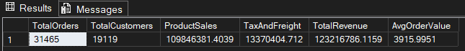
31,465 orders | 19,119 customers | product sales $109,846,381.40 | tax and freight $13,370,404.71 | total revenue $123,216,786.12 | average order value $3,915.99
Insight: Product sales plus tax and freight give the total revenue exactly ($109.85M + $13.37M = $123.22M), so all revenue figures in this report can be traced back to one of these two measures.
Q22. Gross profit and margin by product category
Question: Which categories actually make money, not just revenue?
SQL QUERY
SELECT
pc.Name AS Category,
SUM(sod.LineTotal) AS ProductSales,
SUM(sod.OrderQty * p.StandardCost) AS ProductCost,
SUM(sod.LineTotal - sod.OrderQty * p.StandardCost) AS GrossProfit,
CAST(100.0 * SUM(sod.LineTotal - sod.OrderQty * p.StandardCost)
/ NULLIF(SUM(sod.LineTotal), 0) AS DECIMAL(6,2)) AS GrossMarginPct
FROM Sales.SalesOrderDetail sod
JOIN Production.Product p ON sod.ProductID = p.ProductID
JOIN Production.ProductSubcategory psc ON p.ProductSubcategoryID = psc.ProductSubcategoryID
JOIN Production.ProductCategory pc ON psc.ProductCategoryID = pc.ProductCategoryID
GROUP BY pc.Name
ORDER BY GrossProfit DESC;
RESULT (SSMS output)
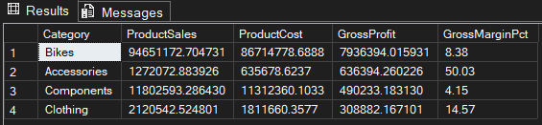
Bikes: $94.65M sales, $7.94M gross profit, 8.38% margin | Accessories: $1.27M sales, $0.64M profit, 50.03% margin | Components: $11.80M sales, $0.49M profit, 4.15% margin | Clothing: $2.12M sales, $0.31M profit, 14.57% margin
Insight: Bikes bring 86% of sales and about 85% of gross profit ($7.94M of $9.37M), but at a thin 8.4% margin. Accessories are only 1.2% of sales, yet give 6.8% of the profit at a 50% margin, and Components earn only 4%. Margins use the current StandardCost, not historical cost, so they are indicative.
Q23. Customer concentration (Pareto)
Question: How much of the revenue comes from the top customers?
SQL QUERY
WITH CustomerSpend AS (
SELECT CustomerID, SUM(TotalDue) AS Spend
FROM Sales.SalesOrderHeader
GROUP BY CustomerID
),
Deciles AS (
SELECT CustomerID, Spend,
NTILE(10) OVER (ORDER BY Spend DESC) AS SpendDecile
FROM CustomerSpend
)
SELECT
SpendDecile,
COUNT(*) AS Customers,
SUM(Spend) AS Revenue,
CAST(100.0 * SUM(Spend) / SUM(SUM(Spend)) OVER () AS DECIMAL(5,2)) AS PctOfRevenue,
CAST(100.0 * SUM(SUM(Spend)) OVER (ORDER BY SpendDecile)
/ SUM(SUM(Spend)) OVER () AS DECIMAL(5,2)) AS CumulativePct
FROM Deciles
GROUP BY SpendDecile
ORDER BY SpendDecile;
RESULT (SSMS output)
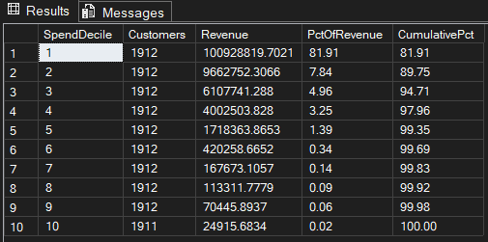
The top 10% of customers (decile 1, 1,912 customers) bring $100.93M = 81.91% of revenue. The top 20% bring 89.75%, the top 50% bring 99.35%.
Insight: Revenue is extremely concentrated: the bottom 50% of customers together add only 0.65%. This matches the customer-type split, because the 635 reseller customers alone bring 73.7% of revenue (Q24, Q29). Losing a few large accounts would hurt far more than losing many small ones.
Q24. Repeat purchase rate by customer type
Question: How loyal are resellers and individual customers?
SQL QUERY
WITH CustomerOrders AS (
SELECT
soh.CustomerID,
CASE WHEN c.StoreID IS NOT NULL THEN 'Store/Reseller' ELSE 'Individual' END AS CustomerType,
COUNT(*) AS Orders
FROM Sales.SalesOrderHeader soh
JOIN Sales.Customer c ON soh.CustomerID = c.CustomerID
GROUP BY soh.CustomerID,
CASE WHEN c.StoreID IS NOT NULL THEN 'Store/Reseller' ELSE 'Individual' END
)
SELECT
CustomerType,
COUNT(*) AS Customers,
SUM(CASE WHEN Orders >= 2 THEN 1 ELSE 0 END) AS RepeatCustomers,
CAST(100.0 * SUM(CASE WHEN Orders >= 2 THEN 1 ELSE 0 END) / COUNT(*) AS DECIMAL(5,2)) AS RepeatRatePct,
CAST(AVG(Orders * 1.0) AS DECIMAL(6,2)) AS AvgOrdersPerCustomer
FROM CustomerOrders
GROUP BY CustomerType
ORDER BY CustomerType;
RESULT (SSMS output)
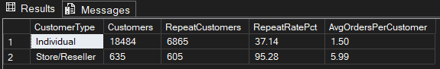
Individual: 18,484 customers, 6,865 repeat (37.14%), 1.50 orders per customer | Store/Reseller: 635 customers, 605 repeat (95.28%), 5.99 orders per customer
Insight: Almost every reseller (95%) orders again, against 37% of individual customers. The business depends on a small, loyal reseller base, while most individual customers buy only once, so converting first-time buyers into repeat buyers is the main growth lever on the individual side.
Q25. Cohort retention by first-order year
Question: Do customers come back in later years?
SQL QUERY
WITH FirstOrder AS (
SELECT CustomerID, MIN(YEAR(OrderDate)) AS CohortYear
FROM Sales.SalesOrderHeader
GROUP BY CustomerID
),
CohortSize AS (
SELECT CohortYear, COUNT(*) AS CohortCustomers
FROM FirstOrder
GROUP BY CohortYear
),
Activity AS (
SELECT DISTINCT CustomerID, YEAR(OrderDate) AS ActiveYear
FROM Sales.SalesOrderHeader
)
SELECT
f.CohortYear,
a.ActiveYear,
cs.CohortCustomers,
COUNT(DISTINCT a.CustomerID) AS ActiveCustomers,
CAST(100.0 * COUNT(DISTINCT a.CustomerID) / cs.CohortCustomers AS DECIMAL(5,2)) AS RetentionPct
FROM FirstOrder f
JOIN Activity a ON a.CustomerID = f.CustomerID
JOIN CohortSize cs ON cs.CohortYear = f.CohortYear
GROUP BY f.CohortYear, a.ActiveYear, cs.CohortCustomers
ORDER BY f.CohortYear, a.ActiveYear;
RESULT (SSMS output)
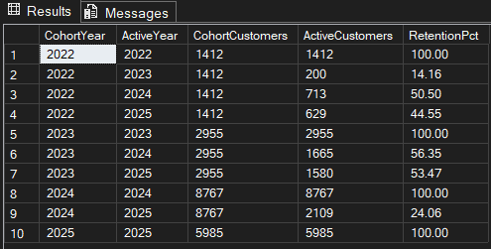
2022 cohort (1,412 customers): 14.16% active in 2023, 50.50% in 2024, 44.55% in 2025 | 2023 cohort (2,955): 56.35% in 2024, 53.47% in 2025 | 2024 cohort (8,767): 24.06% in 2025 | 2025 cohort: 5,985 new customers
Insight: Customers who joined in 2022 and 2023 come back at about 50% or more in later years, while the 2024 cohort shows only 24% (2025 is a partial year). The 2024 cohort is much larger and is consistent with the surge of one-time individual buyers (V4), which would explain its lower retention. The four cohorts add up to the 19,119 customers.
Q26. Full RFM segmentation
Question: Which customer segments should marketing target?
SQL QUERY
WITH CustomerStats AS (
SELECT
CustomerID,
MAX(OrderDate) AS LastOrderDate,
COUNT(*) AS OrderCount,
SUM(TotalDue) AS TotalSpend
FROM Sales.SalesOrderHeader
GROUP BY CustomerID
),
Scored AS (
SELECT
CustomerID, OrderCount, TotalSpend,
NTILE(4) OVER (ORDER BY LastOrderDate ASC) AS R_Score, -- 4 = most recent
CASE WHEN OrderCount = 1 THEN 1
WHEN OrderCount = 2 THEN 2
WHEN OrderCount <= 4 THEN 3
ELSE 4 END AS F_Score,
NTILE(4) OVER (ORDER BY TotalSpend ASC) AS M_Score -- 4 = highest spend
FROM CustomerStats
),
Segmented AS (
SELECT *,
CASE
WHEN R_Score = 4 AND F_Score >= 3 AND M_Score = 4 THEN 'Champions'
WHEN R_Score >= 3 AND F_Score >= 3 THEN 'Loyal'
WHEN R_Score >= 3 AND F_Score <= 2 THEN 'Recent / Potential'
WHEN R_Score <= 2 AND F_Score >= 3 THEN 'At Risk'
ELSE 'Lost / Low value'
END AS Segment
FROM Scored
)
SELECT
Segment,
COUNT(*) AS Customers,
SUM(TotalSpend) AS TotalSpend,
CAST(AVG(TotalSpend) AS DECIMAL(12,2)) AS AvgSpend,
CAST(100.0 * SUM(TotalSpend) / SUM(SUM(TotalSpend)) OVER () AS DECIMAL(5,2)) AS PctOfRevenue
FROM Segmented
GROUP BY Segment
ORDER BY TotalSpend DESC;
RESULT (SSMS output)
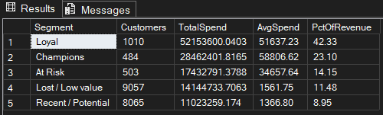
Loyal: 1,010 customers, 42.33% of revenue | Champions: 484 customers, 23.10% | At Risk: 503 customers, 14.15% | Lost / Low value: 9,057 customers, 11.48% | Recent / Potential: 8,065 customers, 8.95%
Insight: Champions and Loyal customers are 1,494 customers (7.8% of all) but bring 65.4% of revenue. The 503 At Risk customers (average spend $34,658) hold $17.4M, which makes them the first group for a retention campaign. The two large groups, Lost / Low value and Recent / Potential (17,122 customers), average only about $1,400 to $1,600. The segment totals match the $123.2M total revenue and 19,119 customers.
Q27. Territory growth, 2023 vs 2024
Question: Which territories grew fastest between the two complete years?
SQL QUERY
WITH TerritoryYear AS (
SELECT st.Name AS Territory, YEAR(soh.OrderDate) AS Yr, SUM(soh.TotalDue) AS Revenue
FROM Sales.SalesOrderHeader soh
JOIN Sales.SalesTerritory st ON soh.TerritoryID = st.TerritoryID
WHERE YEAR(soh.OrderDate) IN (2023, 2024)
GROUP BY st.Name, YEAR(soh.OrderDate)
),
Pivoted AS (
SELECT Territory,
SUM(CASE WHEN Yr = 2023 THEN Revenue ELSE 0 END) AS Revenue2023,
SUM(CASE WHEN Yr = 2024 THEN Revenue ELSE 0 END) AS Revenue2024
FROM TerritoryYear
GROUP BY Territory
)
SELECT
Territory,
Revenue2023,
Revenue2024,
CAST(100.0 * (Revenue2024 - Revenue2023) / NULLIF(Revenue2023, 0) AS DECIMAL(7,2)) AS GrowthPct,
RANK() OVER (ORDER BY (Revenue2024 - Revenue2023) / NULLIF(Revenue2023, 0) DESC) AS GrowthRank
FROM Pivoted
ORDER BY GrowthRank;
RESULT (SSMS output)
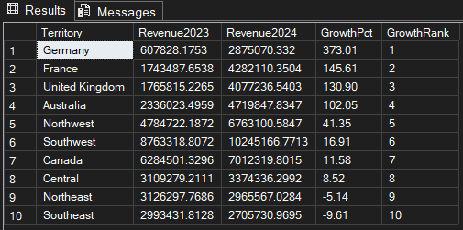
Germany +373.01% ($0.61M to $2.88M) | France +145.61% | United Kingdom +130.90% | Australia +102.05% | Northwest +41.35% | Southwest +16.91% | Canada +11.58% | Central +8.52% | Northeast -5.14% | Southeast -9.61%
Insight: Germany has the lowest total revenue (Q6) only because it started small; it is the fastest-growing territory. Growth comes from the individual-driven international markets (Germany, France, UK, Australia), while the three reseller-heavy territories (Central, Northeast, Southeast; V6) are flat or shrinking. The territory totals add up to the 2023 and 2024 yearly revenue in Q5.
Q28. Discount impact by product category
Question: How much revenue is given away as discounts?
SQL QUERY
SELECT
pc.Name AS Category,
SUM(sod.OrderQty * sod.UnitPrice) AS GrossSales,
SUM(sod.OrderQty * sod.UnitPrice * sod.UnitPriceDiscount) AS DiscountGiven,
CAST(100.0 * SUM(sod.OrderQty * sod.UnitPrice * sod.UnitPriceDiscount)
/ NULLIF(SUM(sod.OrderQty * sod.UnitPrice), 0) AS DECIMAL(5,2)) AS DiscountPct
FROM Sales.SalesOrderDetail sod
JOIN Production.Product p ON sod.ProductID = p.ProductID
JOIN Production.ProductSubcategory psc ON p.ProductSubcategoryID = psc.ProductSubcategoryID
JOIN Production.ProductCategory pc ON psc.ProductCategoryID = pc.ProductCategoryID
GROUP BY pc.Name
ORDER BY DiscountGiven DESC;
RESULT (SSMS output)
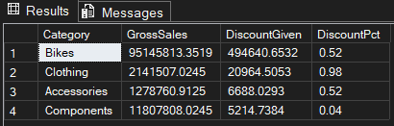
Bikes: $494,641 discount (0.52% of gross sales) | Clothing: $20,965 (0.98%) | Accessories: $6,688 (0.52%) | Components: $5,215 (0.04%)
Insight: Discounts are small: $0.53M in total, 0.48% of gross sales, so they are not what keeps Bike margins low. Bikes carry 94% of the discount dollars, and Clothing has the highest rate (0.98%). Gross sales of $110.37M minus these discounts give the $109.85M product sales of Q21, which is a useful reconciliation.
Q29. Sales channel: online vs sales rep
Question: Which channel brings the revenue?
SQL QUERY
SELECT
CASE WHEN OnlineOrderFlag = 1 THEN 'Online' ELSE 'Sales rep (offline)' END AS Channel,
COUNT(*) AS Orders,
SUM(TotalDue) AS Revenue,
AVG(TotalDue) AS AvgOrderValue,
CAST(100.0 * SUM(TotalDue) / SUM(SUM(TotalDue)) OVER () AS DECIMAL(5,2)) AS PctOfRevenue
FROM Sales.SalesOrderHeader
GROUP BY CASE WHEN OnlineOrderFlag = 1 THEN 'Online' ELSE 'Sales rep (offline)' END
ORDER BY Revenue DESC;
RESULT (SSMS output)
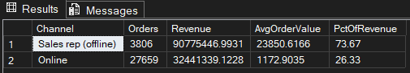
Sales rep (offline): 3,806 orders, $90,775,446.99, AOV $23,850.62, 73.67% of revenue | Online: 27,659 orders, $32,441,339.12, AOV $1,172.90, 26.33%
Insight: These numbers are identical to the customer-type split in Q9: every online order comes from an individual customer and every sales-rep order from a store/reseller. So the reseller business is the sales-rep channel (74% of revenue from 12% of orders), and online is the high-volume, low-value channel.
Q30. Market basket: subcategories bought together
Question: Which products are most often bought in the same order?
SQL QUERY
WITH OrderSubcategories AS (
SELECT DISTINCT sod.SalesOrderID, p.ProductSubcategoryID
FROM Sales.SalesOrderDetail sod
JOIN Production.Product p ON sod.ProductID = p.ProductID
WHERE p.ProductSubcategoryID IS NOT NULL
)
SELECT TOP 10
s1.Name AS Subcategory_A,
s2.Name AS Subcategory_B,
COUNT(*) AS OrdersTogether
FROM OrderSubcategories a
JOIN OrderSubcategories b
ON a.SalesOrderID = b.SalesOrderID
AND a.ProductSubcategoryID < b.ProductSubcategoryID
JOIN Production.ProductSubcategory s1 ON a.ProductSubcategoryID = s1.ProductSubcategoryID
JOIN Production.ProductSubcategory s2 ON b.ProductSubcategoryID = s2.ProductSubcategoryID
GROUP BY s1.Name, s2.Name
ORDER BY OrdersTogether DESC;
RESULT (SSMS output)
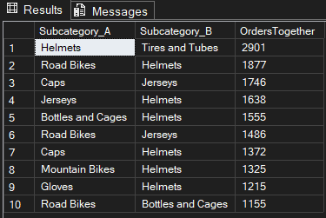
Top pairs: Helmets + Tires and Tubes (2,901 orders) | Road Bikes + Helmets (1,877) | Caps + Jerseys (1,746) | Jerseys + Helmets (1,638) | Bottles and Cages + Helmets (1,555)
Insight: Helmets appear in 7 of the top 10 pairs, so they are the anchor accessory. Together with Q22 this points to a clear action: Accessories earn a 50% margin while Bikes earn 8%, so bundling a helmet (and bottle and cage) with every bike would add profit without any discount.
Q31. Seasonality index by calendar month
Question: Which months are strong and which are weak?
SQL QUERY
WITH MonthlyRevenue AS (
SELECT YEAR(OrderDate) AS Yr, MONTH(OrderDate) AS Mth, SUM(TotalDue) AS Revenue
FROM Sales.SalesOrderHeader
WHERE OrderDate >= '2023-01-01' AND OrderDate < '2025-01-01'
GROUP BY YEAR(OrderDate), MONTH(OrderDate)
)
SELECT
Mth,
AVG(Revenue) AS AvgMonthlyRevenue,
CAST(100.0 * AVG(Revenue) / AVG(AVG(Revenue)) OVER () AS DECIMAL(6,1)) AS SeasonalIndex
FROM MonthlyRevenue
GROUP BY Mth
ORDER BY Mth;
RESULT (SSMS output)
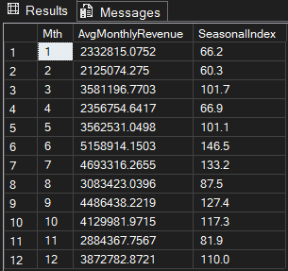
Strongest: Jun 146.5 | Jul 133.2 | Sep 127.4 | Oct 117.3. Weakest: Feb 60.3 | Jan 66.2 | Apr 66.9. (100 = average month, based on the complete years 2023 and 2024.)
Insight: Sales peak in summer and early autumn and are lowest in January, February and April. June is normally the strongest month, which makes the collapse of June 2025 (V2, V3) even more unusual and supports treating May and June 2025 as unreliable data.
Q32. 3-month moving average of revenue
Question: What is the underlying revenue trend once the monthly swings are smoothed out?
SQL QUERY
WITH MonthlyRevenue AS (
SELECT YEAR(OrderDate) AS Yr, MONTH(OrderDate) AS Mth, SUM(TotalDue) AS Revenue
FROM Sales.SalesOrderHeader
WHERE OrderDate >= '2022-06-01' AND OrderDate < '2025-05-01'
GROUP BY YEAR(OrderDate), MONTH(OrderDate)
)
SELECT
Yr, Mth, Revenue,
CAST(AVG(Revenue) OVER (ORDER BY Yr, Mth ROWS BETWEEN 2 PRECEDING AND CURRENT ROW) AS DECIMAL(14,2)) AS MovingAvg3M
FROM MonthlyRevenue
ORDER BY Yr, Mth;
RESULT (SSMS output)
Yr | Mth | Revenue | MovingAvg3M
2022 | 6 | $2,244,313.14 | $2,244,313.14
2022 | 7 | $1,868,508.36 | $2,056,410.75
2022 | 8 | $1,483,277.04 | $1,865,366.18
2022 | 9 | $3,183,714.32 | $2,178,499.91
2022 | 10 | $2,543,935.27 | $2,403,642.21
2022 | 11 | $1,603,313.51 | $2,443,654.37
2022 | 12 | $2,807,217.25 | $2,318,155.34
2023 | 1 | $2,325,568.60 | $2,245,366.45
2023 | 2 | $1,620,826.10 | $2,251,203.98
2023 | 3 | $3,336,347.47 | $2,427,580.72
2023 | 4 | $1,871,923.50 | $2,276,365.69
2023 | 5 | $3,452,924.45 | $2,887,065.14
2023 | 6 | $4,610,647.22 | $3,311,831.72
2023 | 7 | $3,840,231.46 | $3,967,934.38
2023 | 8 | $2,442,451.18 | $3,631,109.95
2023 | 9 | $3,881,724.19 | $3,388,135.61
2023 | 10 | $2,858,060.20 | $3,060,745.19
2023 | 11 | $2,097,153.13 | $2,945,645.84
2023 | 12 | $3,176,848.17 | $2,710,687.16
2024 | 1 | $2,340,061.55 | $2,538,020.95
2024 | 2 | $2,629,322.45 | $2,715,410.72
2024 | 3 | $3,826,046.07 | $2,931,810.02
2024 | 4 | $2,841,585.78 | $3,098,984.77
2024 | 5 | $3,672,137.65 | $3,446,589.83
2024 | 6 | $5,707,181.09 | $4,073,634.84
2024 | 7 | $5,546,401.07 | $4,975,239.93
2024 | 8 | $3,724,394.90 | $4,992,659.02
2024 | 9 | $5,091,152.26 | $4,787,316.08
2024 | 10 | $5,401,903.75 | $4,739,150.30
2024 | 11 | $3,671,582.38 | $4,721,546.13
2024 | 12 | $4,568,717.58 | $4,547,401.24
2025 | 1 | $4,783,231.67 | $4,341,177.21
2025 | 2 | $3,987,943.62 | $4,446,630.96
2025 | 3 | $5,585,675.81 | $4,785,617.03
2025 | 4 | $5,847,164.69 | $5,140,261.38

The 3-month average rises from $2.24M (Jun 2022) to $5.14M (Apr 2025), a 2.3 times increase. The highest value is the last one, Apr 2025.
Insight: After smoothing, the trend is clearly upward, with a dip in early 2025 (from $4.99M in Aug 2024 to $4.34M in Jan 2025) followed by a recovery. The query covers Jun 2022 to Apr 2025 only: it leaves out the 2-day stub of May 2022 and the unreliable May and June 2025 (V2). The first two rows average fewer than 3 months.

Validation checks (05_validation_checks.sql)
V1. Data period
Question: What period do the orders actually cover? (Answer to: why does a 2025 project show older dates?)
SQL QUERY
SELECT MIN(OrderDate) AS FirstOrder, MAX(OrderDate) AS LastOrder
FROM Sales.SalesOrderHeader;
RESULT (SSMS output)

FirstOrder = 2022-05-30 | LastOrder = 2025-06-29
Insight: AdventureWorks2025 is the database version. The order data runs from 30 May 2022 to 29 June 2025, which matches Q2.
V2. Orders per day, May to June 2025
Question: Is June 2025 really a partial month? Where does the sharp revenue drop start?
SQL QUERY
SELECT CAST(OrderDate AS DATE) AS OrderDay, COUNT(*) AS Orders, SUM(TotalDue) AS Revenue
FROM Sales.SalesOrderHeader
WHERE OrderDate >= '2025-05-01'
GROUP BY CAST(OrderDate AS DATE)
ORDER BY OrderDay;
RESULT (SSMS output)
Result summary: before and after 30 May 2025
Period | Days | Orders per day | Revenue per day | Avg order value
1 to 29 May 2025 | 29 | 74.0 | $72,576 | $980
30 May to 29 Jun 2025 | 31 | 31.5 | $1,812 | $58

Result rows: 25 May to 3 June 2025 (10 of the 60 rows)
OrderDay | Orders | Revenue
2025-05-25 | 79 | $76,834.67
2025-05-26 | 73 | $64,179.26
2025-05-27 | 89 | $87,191.78
2025-05-28 | 67 | $67,360.56
2025-05-29 | 52 | $53,454.74
2025-05-30 | 37 | $2,027.44
2025-05-31 | 34 | $1,673.29
2025-06-01 | 34 | $1,985.50
2025-06-02 | 24 | $1,437.97
2025-06-03 | 29 | $1,360.93

The result has 60 daily rows (1 May to 29 Jun 2025). Up to 29 May, a day brings about 74 orders and $72,576. From 30 May, a day brings about 31 orders and only $1,812. The break happens on 30 May.
Insight: June 2025 is not a partial month: there are orders on every day up to 29 June. What changes on 30 May is the order value. Orders per day fall by more than half, but revenue per day falls by about 97%, so the average order is worth about $58 instead of about $980. This query does not show why (for example, large reseller orders may be missing at the end of the data), so May and June 2025 should be treated as unreliable and left out of trend statements. The cause can be checked with the customer type and category queries added to 05_validation_checks.sql.
V3. Monthly orders and revenue, Nov 2024 to Jun 2025
Question: In which month does the drop start, and does it come from order count or order value?
SQL QUERY
SELECT YEAR(OrderDate) AS Yr, MONTH(OrderDate) AS Mth,
COUNT(*) AS Orders, SUM(TotalDue) AS Revenue
FROM Sales.SalesOrderHeader
WHERE OrderDate >= '2024-11-01'
GROUP BY YEAR(OrderDate), MONTH(OrderDate)
ORDER BY Yr, Mth;
RESULT (SSMS output)
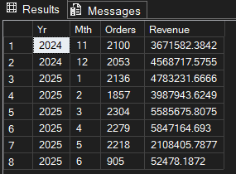
Orders per month stay between 1,857 and 2,304 until May 2025 (2,218). Revenue is $5.85M in Apr 2025, $2.11M in May and $52,478 in Jun 2025 (905 orders).
Insight: The revenue fall comes from order value, not order count: May 2025 has about the same number of orders as earlier months, but each order is worth about $950 instead of about $2,500 in Mar and Apr 2025. June has 905 orders at about $58 each.
V4. Quarter by customer type
Question: Did the average order value drop come from a shift in the customer mix?
SQL QUERY
SELECT
YEAR(soh.OrderDate) AS OrderYear,
DATEPART(QUARTER, soh.OrderDate) AS OrderQuarter,
CASE WHEN c.StoreID IS NOT NULL THEN 'Store/Reseller' ELSE 'Individual' END AS CustomerType,
COUNT(*) AS Orders,
AVG(soh.TotalDue) AS AvgOrderValue,
SUM(soh.TotalDue) AS Revenue
FROM Sales.SalesOrderHeader soh
JOIN Sales.Customer c ON soh.CustomerID = c.CustomerID
GROUP BY YEAR(soh.OrderDate), DATEPART(QUARTER, soh.OrderDate),
CASE WHEN c.StoreID IS NOT NULL THEN 'Store/Reseller' ELSE 'Individual' END
ORDER BY OrderYear, OrderQuarter, CustomerType;
RESULT (SSMS output)
OrderYear | OrderQuarter | CustomerType | Orders | AvgOrderValue | Revenue
2022 | 2 | Individual | 151 | $3,595.12 | $542,864
2022 | 2 | Store/Reseller | 113 | $20,211.19 | $2,283,865
2022 | 3 | Individual | 464 | $3,563.40 | $1,653,416
2022 | 3 | Store/Reseller | 190 | $25,695.18 | $4,882,083
2022 | 4 | Individual | 592 | $3,535.49 | $2,093,010
2022 | 4 | Store/Reseller | 182 | $26,711.30 | $4,861,456
2023 | 1 | Individual | 588 | $3,561.42 | $2,094,114
2023 | 1 | Store/Reseller | 186 | $27,895.85 | $5,188,628
2023 | 2 | Individual | 673 | $2,974.92 | $2,002,121
2023 | 2 | Store/Reseller | 279 | $28,435.03 | $7,933,374
2023 | 3 | Individual | 705 | $2,047.64 | $1,443,587
2023 | 3 | Store/Reseller | 317 | $27,510.47 | $8,720,820
2023 | 4 | Individual | 771 | $1,947.15 | $1,501,249
2023 | 4 | Store/Reseller | 311 | $21,320.94 | $6,630,813
2024 | 1 | Individual | 867 | $1,947.69 | $1,688,643
2024 | 1 | Store/Reseller | 314 | $22,633.08 | $7,106,787
2024 | 2 | Individual | 1,220 | $1,792.43 | $2,186,765
2024 | 2 | Store/Reseller | 383 | $26,198.80 | $10,034,140
2024 | 3 | Individual | 4,882 | $670.77 | $3,274,720
2024 | 3 | Store/Reseller | 454 | $24,421.21 | $11,087,228
2024 | 4 | Individual | 5,677 | $839.08 | $4,763,471
2024 | 4 | Store/Reseller | 447 | $19,862.94 | $8,878,732
2025 | 1 | Individual | 5,848 | $861.98 | $5,040,870
2025 | 1 | Store/Reseller | 449 | $20,748.29 | $9,315,981
2025 | 2 | Individual | 5,221 | $796.11 | $4,156,508
2025 | 2 | Store/Reseller | 181 | $21,279.23 | $3,851,540

Individual orders jump from 1,220 (2024-Q2) to 4,882 (2024-Q3), while individual AOV falls from $1,792 to $671. Reseller orders stay between 314 and 454 per quarter from 2024 to 2025-Q1, at an AOV of $19.9K to $26.2K. In 2025-Q2, reseller orders drop to 181.
Insight: This confirms that the AOV drop is a customer-mix effect. Individual customers go from 18% of quarterly revenue in 2024-Q2 to 35% in 2025-Q1, while resellers still bring most of the revenue. Individual AOV had also been falling for a long time (from $3,595 in 2022-Q2 to $1,792 in 2024-Q2), then fell again with the 2024-Q3 volume jump. The 2025-Q2 reseller drop (181 orders against 449 in Q1) matches the end-of-data drop seen in V2 and V3.
V5. Like-for-like growth, Jan to Jun
Question: How does revenue in Jan to Jun 2025 compare with Jan to Jun 2024?
SQL QUERY
SELECT
YEAR(OrderDate) AS OrderYear,
COUNT(*) AS Orders,
SUM(TotalDue) AS Revenue
FROM Sales.SalesOrderHeader
WHERE (OrderDate >= '2024-01-01' AND OrderDate < '2024-07-01')
OR (OrderDate >= '2025-01-01' AND OrderDate < '2025-07-01')
GROUP BY YEAR(OrderDate)
ORDER BY OrderYear;
RESULT (SSMS output)
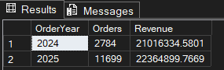
2024: 2,784 orders, $21,016,334.58 | 2025: 11,699 orders, $22,364,899.77. Orders grow 4.2 times, revenue only +6.4%.
Insight: The +6.4% understates the growth, because May and June 2025 are unusually low (V2, V3). On the same months through April, revenue is $20.20M in 2025 against $11.64M in 2024, which is +74% (from the running totals in Q12).
V6. Territories by order value and customer mix
Question: Is low revenue in a territory underperformance, or a different customer mix?
SQL QUERY
SELECT
st.Name AS Territory,
COUNT(*) AS Orders,
SUM(soh.TotalDue) AS Revenue,
AVG(soh.TotalDue) AS AvgOrderValue,
SUM(CASE WHEN c.StoreID IS NOT NULL THEN 1 ELSE 0 END) AS ResellerOrders,
CAST(100.0 * SUM(CASE WHEN c.StoreID IS NOT NULL THEN 1 ELSE 0 END) / COUNT(*) AS DECIMAL(5,2)) AS ResellerOrderPct
FROM Sales.SalesOrderHeader soh
JOIN Sales.SalesTerritory st ON soh.TerritoryID = st.TerritoryID
JOIN Sales.Customer c ON soh.CustomerID = c.CustomerID
GROUP BY st.Name
ORDER BY Revenue DESC;
RESULT (SSMS output)
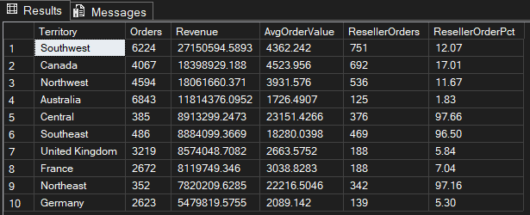
Central 97.66%, Northeast 97.16% and Southeast 96.50% of orders are reseller orders (AOV $23.2K, $22.2K and $18.3K). Germany is 5.30% reseller with an AOV of $2,089, and Australia is 1.83% reseller with an AOV of $1,726.
Insight: Central, Northeast and Southeast are almost entirely reseller territories with few, large orders, so their lower revenue is not underperformance. Germany and Australia are individual-driven markets, and should be compared with each other and with the UK and France, not with the reseller territories. Southwest, Canada and Northwest are mixed (12% to 17% reseller) with an AOV of $3.9K to $4.5K.
V7. Which revenue measure is used
Question: How do TotalDue, SubTotal and LineTotal compare?
SQL QUERY
SELECT
(SELECT SUM(TotalDue) FROM Sales.SalesOrderHeader) AS TotalDue_Revenue,
(SELECT SUM(SubTotal) FROM Sales.SalesOrderHeader) AS SubTotal_ProductSales,
(SELECT SUM(LineTotal) FROM Sales.SalesOrderDetail) AS LineTotal_ProductSales;
RESULT (SSMS output)
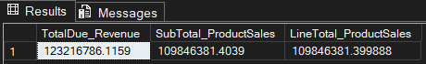
TotalDue = $123,216,786.12 | SubTotal = $109,846,381.40 | LineTotal = $109,846,381.40
Insight: SubTotal and LineTotal agree, so $109.85M is the product sales figure. TotalDue is higher by $13.37M (about 12%) because it includes tax and freight. This is why Bikes are 86.17% of product sales (LineTotal basis) but only 76.8% of TotalDue.

